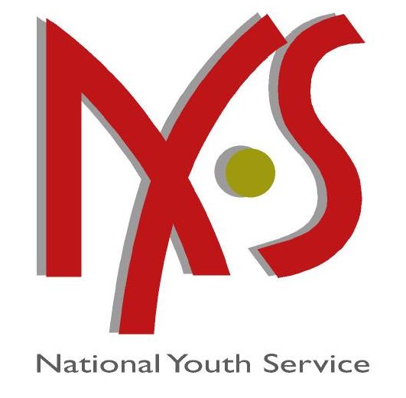



ATTENTION:

Dear Sir/Madam

As a result of your successful candidature for the advertised Expanded Public Works (EPWP) National Youth Service (NYS) Programme for Grahamstown Prison Project it gives us pleasure to inform you that you’ve been accepted. Your date of assumption of training will commence on the ____________________for a period of nine months.

Post : NYS Learner
Stipend (For theoretic training) : R660.00 per month
Stipend (On site practical training) : R1460.00 per month
Establishment : EPWP-NYS
Centre :

Stipends are not fixed but paid at a daily rate where applicable for the period attended.
Official starting time and training hours are from 08:30 to 16:30.

Your appointment is subject to the provision of the Public Service Act, 1994 with exclusion made in the contract designed for the programme.

It is trusted that you will be very happy and successful in the Service of the Department of Public Works.

Yours Faithfully,

_________________________________
MR/MS
MANAGER: EPWP – NYS
DATE:

I ___________________________ID No.:_____________________ACCEPT/REJECT

the offer as EPWP/NYS Learner.

Signature: _________________________

Date: _____________________________

Cell/Tel: ___________________________

